Ideation Phase
Brainstorm & Idea Prioritization

Date: | 6 Feb 2026
Team ID: | LTVIP2026TMIDS73160
Project Name: | Househunt: finding your perfect rental home
Maximum Marks: | 4 Marks

🌟 Ideation Phase
The ideation phase focuses on identifying real-world problems and generating innovative digital solutions through structured brainstorming. This phase encourages creativity, collaboration, and problem analysis to design a system that effectively addresses challenges in the house rental domain.

Step-1: Team Gathering, Collaboration and Selecting the Problem Statement
The team gathered to discuss common difficulties faced by house owners and renters in the traditional rental process. Through empathy mapping and user journey analysis, it was observed that existing rental systems are mostly manual, time-consuming, and lack transparency.
After multiple discussions and idea evaluations, the following problem statement was selected:
How can we design a digital platform that enables house owners and renters to manage rental properties efficiently, securely, and transparently using modern web technologies?
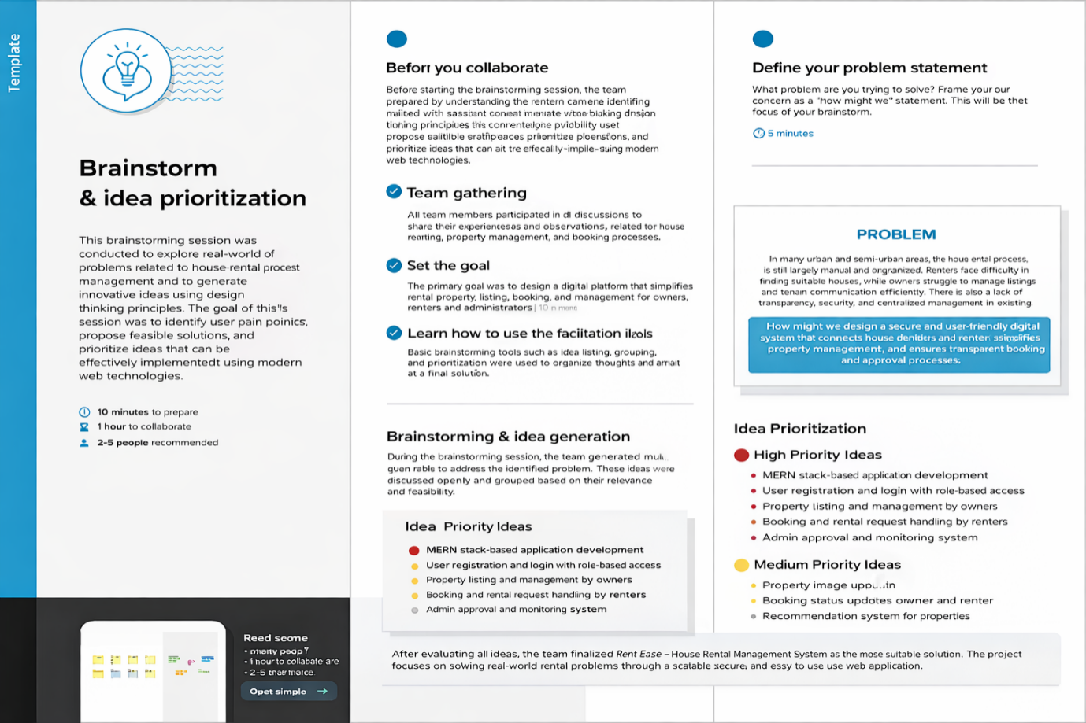

💡 Step-2: Brainstorming, Idea Listing and Grouping
During the brainstorming session, the team generated multiple ideas to solve the identified problem. The ideas were grouped based on functionality and feasibility.
🧠 Brainstormed Ideas
- Develop a MERN stack–based house rental application
- Enable user registration and login with role-based access (Admin, Owner, Renter)
- Allow owners to add, update, and delete rental properties
- Enable renters to browse and book available properties
- Implement admin approval for owner accounts
- Secure authentication using JWT
- Store data using MongoDB database
- Display property images and detailed descriptions
- Implement booking status tracking
- Provide responsive UI for desktop and mobile devices.

🎯 Step-3: Idea Prioritization
The generated ideas were evaluated based on feasibility, impact, and ease of implementation. Based on this evaluation, ideas were categorized into priority levels.
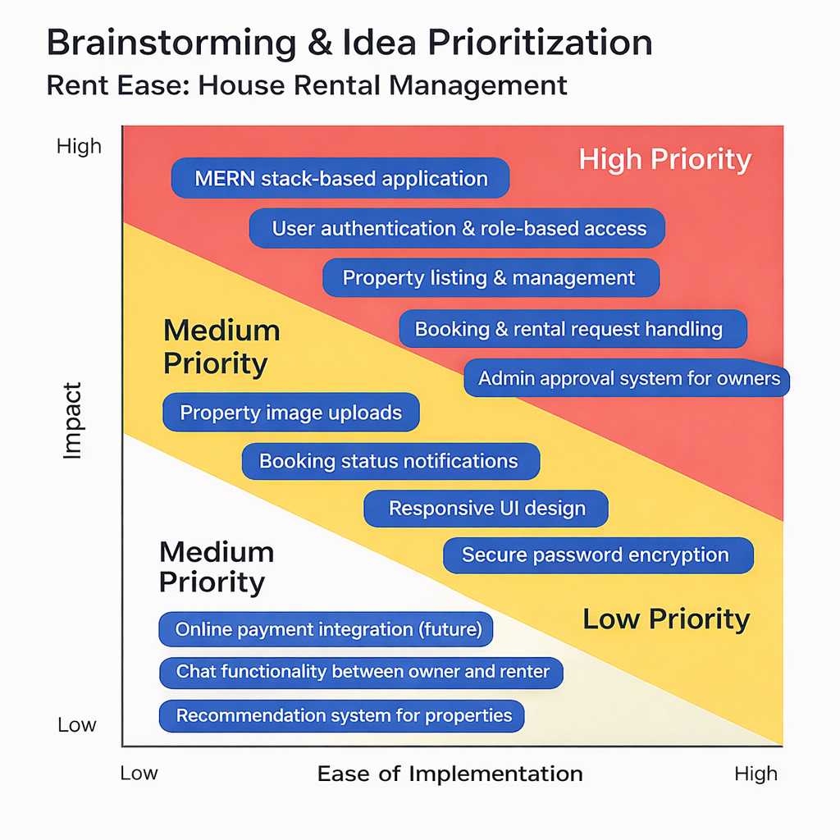
Ideas were evaluated based on feasibility, impact, and ease of implementation:
🔴 High Priority
- MERN stack–based application architecture
- User authentication and role-based access
- Property listing and management
- Booking and rental request handling
- Admin approval system for owners
🟡 Medium Priority
- Property image uploads
- Booking status notifications
- Responsive UI design
- Secure password encryption
⚪ Low Priority
- Online payment gateway integration (future enhancement)
- Chat system between owner and renter
- Recommendation system for properties

